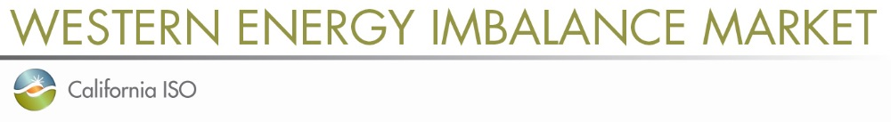

Stakeholder Comments Template

Western EIM Regional Issues Forum – Revised Operating Guidelines

This template has been created for submission of stakeholder comments on the revised Operating Guidelines that were published on August 12, 2021. The revised Operating Guidelines, stakeholder meeting presentation, and other information related to the Western EIM Regional Issues Forum (RIF) may be found on the RIF webpage at: http://www.caiso.com/informed/Pages/MeetingsEvents/MiscellaneousStakeholderMeetings/Default.aspx

Upon completion of this template, please submit it to initiativecomments@caiso.com.
Submissions are requested by close of business on August 25, 2021.

Submitted by | Organization | Date Submitted
(submitter name and phone number) | (organization name) | (date)

- Please provide a summary of your organization’s comments on the proposed changes to the revised Operating Guidelines:

- Please provide your organization’s comments specific to the proposed changes to the Purpose and Responsibilities section of the document. Please include any red-line edits:

- Please provide your organization’s comments specific to the proposed changes to the Composition and Governance, Membership section of the document. Please include any red-line edits:

- Please provide your organization’s comments specific to the proposed changes to the Composition and Governance, Selection Process section of the document. Please include any red-line edits:

- Please provide any additional changes your organization would like to see made to the revised Operating Guidelines:

